Install wikiStax

The prerequisites for wikiStax are:

php8.2 or php8.3
MariaDB or MySQL with root access.

Grab a copy of wikiStax from github.

Copy the files over to where you want to install wikiStax to, in this instance I will be locating them in the /var/www/html/wikistaxdeve directory.
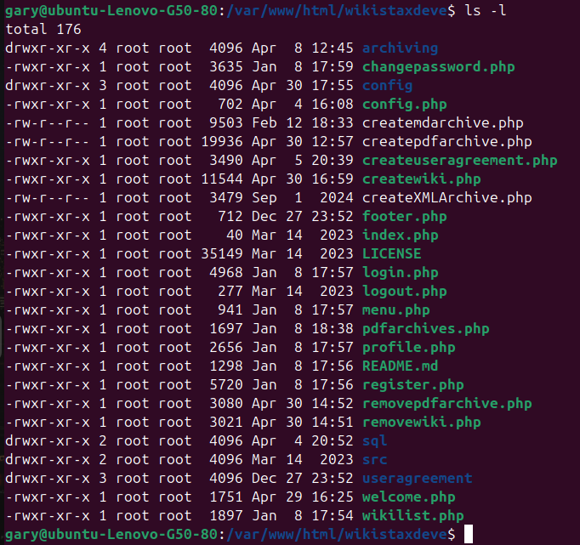
Create the wikiStax database:

Enter MariaDB or MySQL:

sudo mysql -u root -p

Create a database:

CREATE DATABASE mwadmin;

You will need to have a database user, if you don’t have one already, create one:

CREATE USER 'wikistax'@'localhost' IDENTIFIED BY 'password';

Grant the permissions to the user.

GRANT ALL PRIVILEGES ON *.* TO 'wikistax'@'localhost';

exit

Move into the www directory

cd /var/www

If needed, make sure the html and recursive directories and files have the correct owner:

sudo chown -R www-data:www-data html

If you are on a shared host with cPanel and/or you have access to phpMyAdmin, do this next step via the the host tools.

Now navigate to the wikiStax/sql database:

cd /var/www/html/wikistax/sql

Import the wikiStax.sql to the wikistax database:

sudo mysql -u root -p wikistax < wikiStax.sql

Move into the root of wikiStax

cd /var/www/html/wikistax

And update the config.php file:

nano config.php

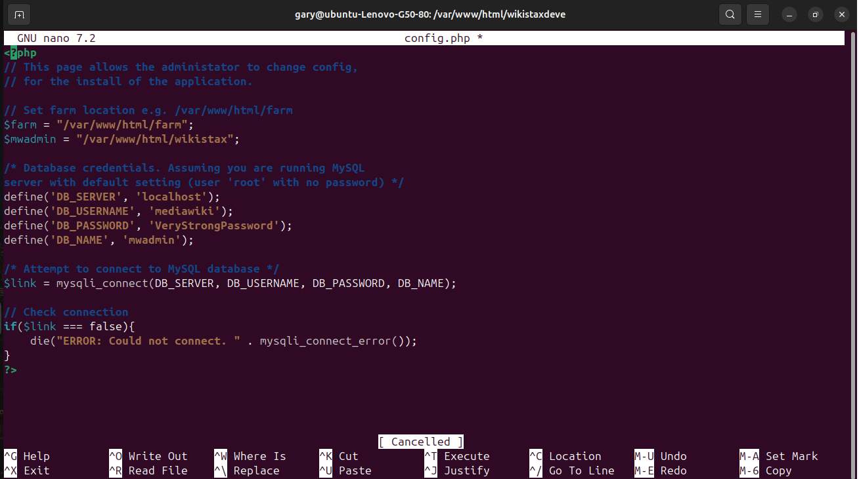
Update the $farm and $mwadmin variables and the database settings. The db server is the address of your server, normally this is localhost depending on how your server is set up. The db username is whatever you have set the password to, and db name is the databases name.

Control O to save, control X to exit nano.

You can now access wikiStax

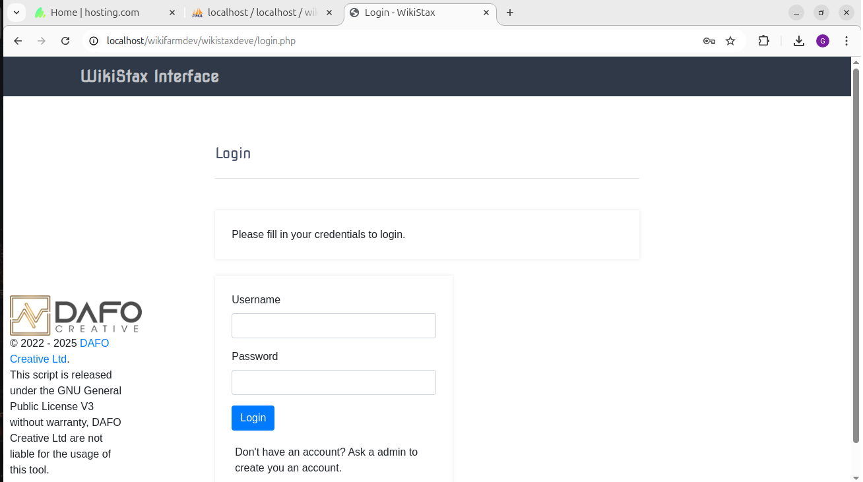
The default username and password are:

U: admin
P: OpenSesame967!

Set up the Wiki Farm
This may take some time and explanation.

The default Vanilla database is a standard install, if you need other extensions you may need to install a standard MediaWiki installation and create your own database and overall farm. With the database you will need to replace the existing wikistax/config/VanillaDB.sql file.

If using the Vanilla database the default superuser is:

U: Wikistax
P: OpenSesame967!

Copy the MediaWiki files to your farm location, in this case /var/www/html/farm

Move the wikistax/config/LocalSettings.php into the farm directory. This may need updating. The default farm creation currently only works with wikis in sub directories. I often have the extensions and permissions in separate files so that if you need to make changes you only need to do it once.

You will now be able to use WikiStax, more documentation is available on this Wiki to guide you through the process.

